YX-4525B Shrinkage packing machine
Operation and Maintenance Manual

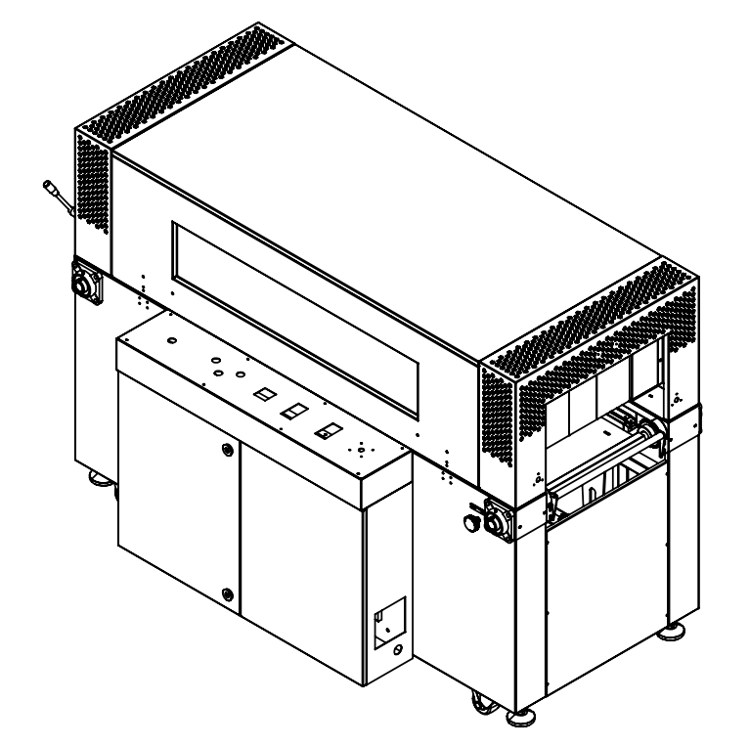

※ Please read this manual carefully before using the machine
※ Subject to any technical changes without notice

When using this machine, please pay attention to the following signs:

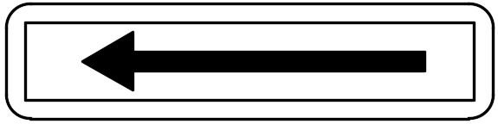
Indicates the direction of transmission operation
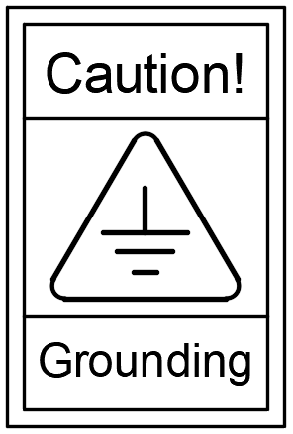

Be sure to be grounded when using

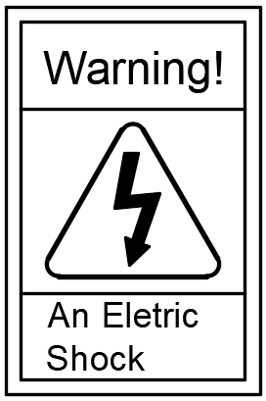
Non professional maintenance personnel are not allowed to open here

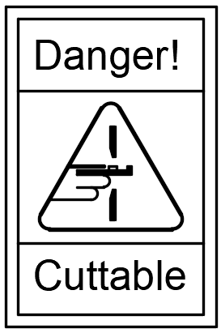

Danger of hand injury or cutting here

Catalogue

1、 Preface
2、 Machine appearance dimension
3、 Name of Machine Panel and Components
4、 Illustrations of Machine Components
5、 Table of Technical Parameters of the Machine
6、 Installation of Machine
7、 Operation Method of Machine
8、 Maintenance of Machine
9、 Circuit Diagram of the Machine
10、 Troubleshooting

- Preface
1. How to refer to and use this manual
A) Please read this manual carefully before using the machine;
B) The manual is the full description of the product, please store it with the machine;
C) If the machine is resold or lent to others, this manual will go with it;
D) Do not damage this manual;
E) Do not delete or modify this manual without permission;
F) If you need to adjust the relevant technical parameters of the machine, please follow the relevant instructions of this manual;
G) Due to continuous improvement and improvement of machine performance, the company reserves the right to modify the machine and manual;
H) If you have any good suggestions on this manual or the machine, please contact our company.

2. Safety precautions
A) The circuit breaker and power cord with the same capacity as the machine must be used. Use a circuit breaker of smaller capacity or
The power cord with smaller wire diameter will cause damage to the circuit or components;
B) When packaging the liquid, it shall be ensured that the liquid will not drip. This machine is a liquid with poor sealing
Packaging ・ may cause machine damage or personal electric shock;
C) Do not use the machine in a highly humid environment, or allow the machine to be exposed to a large amount of water evaporation;
D) Do not use or place the machine in dusty places;
E) The parts with high temperature warning signs may be exposed to high temperature during operation, so please do not touch them with your hands;
F) Do not turn on heating without running the air, which may cause damage to the heating pipe and fire hazard
Insurance;

3. Overview
Thank you very much for your support. Because of your correct choice, you have a safe, practical and efficient thermostatic shrink packaging machine.
This machine is suitable for the appearance packaging of products such as printing, color boxes, greeting cards, photo albums, photo frames, medicine and daily chemicals.
After packaging, it has beautiful appearance, dust-proof, moisture-proof and damage proof functions. Improved image and low packaging cost.

This machine has the following features:
A. Combined with advanced contraction air transportation technology, and improved and unique design and manufacture, the air transportation is uniform and the contraction effect is good;
B. Made of high-quality carbon steel or stainless steel with reasonable structure and long heating tunnel;
C. The stainless steel heating pipe is adopted, with long service life and high energy efficiency;
D. The switch, temperature controller and other main electrical parts are made of famous factory components, which are stable in operation and low in failure rate;
E. The conveying and air conveying motors are made of famous factory components, which have strong power and can work continuously for a long time;
F. The transmission motor adopts the wellhead frequency converter for stepless speed regulation, with stable speed regulation performance;
G. Wellhead insulation cord fabric is used to greatly reduce heat loss;
H. Shrinkage temperature, conveying speed and air volume can be adjusted;
1. The conveyor roller is a new type of roller, coated with silica gel, which is resistant to high temperature, abrasion, hot film and deformation, and can be used for a long time. And can choose the ordinary tight shaft type according to the product size;
This machine is suitable for POF, PVC, PP and other shrink films.

- Machine appearance dimension
Length 2100MM,Width 1400MM，Height1550MM

- Name of Machine Panel and Components

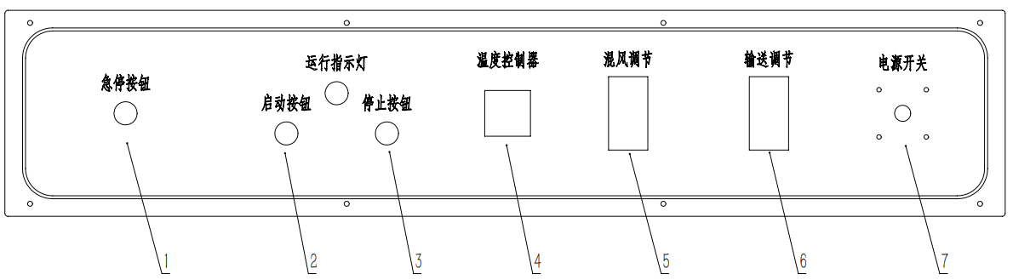

1. Emergency stop: emergency stop;
2. Start button: start the machine;
3. Stop button: stop the machine heating;
4. Temperature controller: set heating temperature;
5. Air mixing regulation: adjust the air volume;
6. Conveying adjustment: adjust the conveying speed of the roller;
7. Power switch: turn off or connect the main power supply of the machine;

- Illustrations of Machine Components
1、Exploded view of fuselage

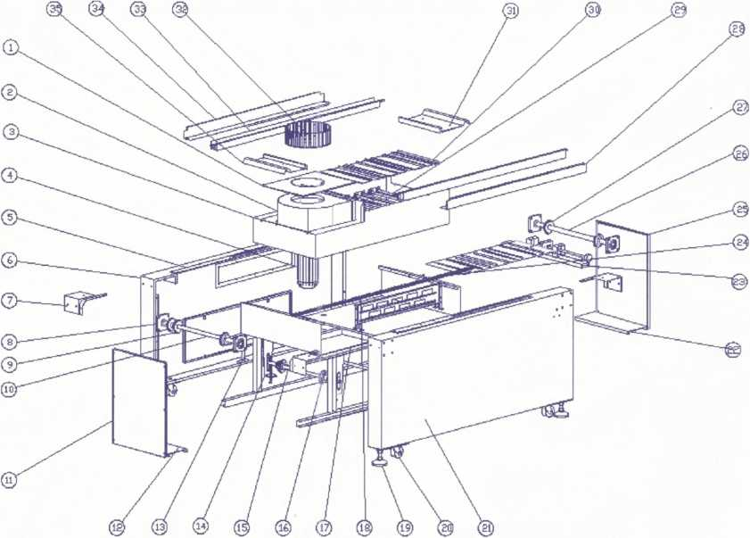

No | Name | Qty | Remark
1 | Ventilation coaming of wind turbine | 1
2 | Wind wheel cover | 1
3 | Lower insulation cotton inner shell | 1
4 | electric machinery | 1
5 | Ventilation net frame on beam | 2 | Left-1pcs. Right-1pcs
6 | Rear sill | 1
7 | Left and right attachment plates | 4
8 | Bearing with seat | 4 | UCF206
9 | Driven sprocket | 2
10 | Driven shaft | 1
11 | Left sealing plate of furnace beam | 1
12 | Horizontal motor mounting base | 1
13 | Chain adjusting lever | 2 | Left-1pcs. Right-1pcs
14 | Conveying tension support | 6 | Left-3pcs. Right-3pcs
15 | Tensioning shaft | 3
16 | Tensioning sprocket | 6
17 | Lower insulation cotton inner partition | 1
18 | Fixing frame of heating pipe | 1
19 | M20 foot cup | 4
20 | 3 inch castors | 4
21 | Front beam | 1
22 | Welding leg connecting plate | 1
23 | Air regulating device | 1
24 | Conveyor chain | 2
25 | Right sealing plate of furnace beam | 1
26 | Driving shaft | 1
27 | Driving sprocket | 3
28 | Lower heat insulation cotton pressing plate | 2
29 | U-shaped heating tube | 9
30 | Wind deflector | 7
31 | Drive shaft guard plate | 1
32 | 12 inch wind wheel | 1
33 | Upper support rail | 2
34 | Thermal insulation cotton pressing plate in beam | 2
35 | Driven shaft guard plate | 1
36
37
38
39
40
41
42
43

- Tunnel explosion diagram

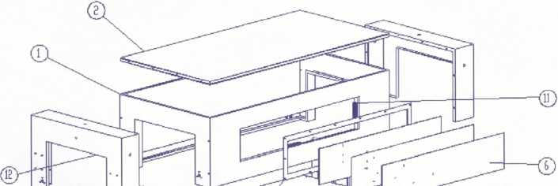

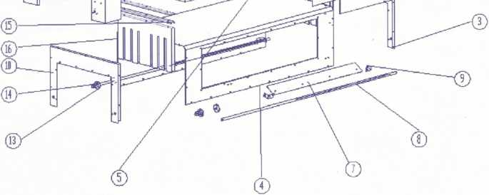

No | Name | Qty | Remark
1 | Furnace stack shell | 1
2 | Top cover of furnace stack shell | 1
3 | Inside the furnace | 1
4 | Inner cover plate of furnace | 1
5 | Tempered glass pressing plate | 1
6 | Tempered white glass | 3
7 | Air distributor | 2 | Left-1pcs. Right-1pcs
8 | Air regulating rod | 2 | Left-1pcs. Right-1pcs
9 | Fixed block of air regulating rod | 4 | Left-2pcs. Right-2pcs
10 | Left cover plate inside the furnace | 1
11 | Silicone tank | 4 | Left-2pcs. Right-2pcs
12 | Mesh cover | 2 | Left-1pcs. Right-1pcs
13 | Fixing sleeve 2 of air adjusting rod | 2 | Left-1pcs. Right-1pcs
14 | Fixing sleeve of air adjusting rod | 2 | Left-1pcs. Right-1pcs
15 | Furnace cloth pressing trough | 4 | Left-2pcs. Right-2pcs
16 | Furnace cloth | 2 | Left-1pcs. Right-1pcs

3、Explosion diagram of distribution box

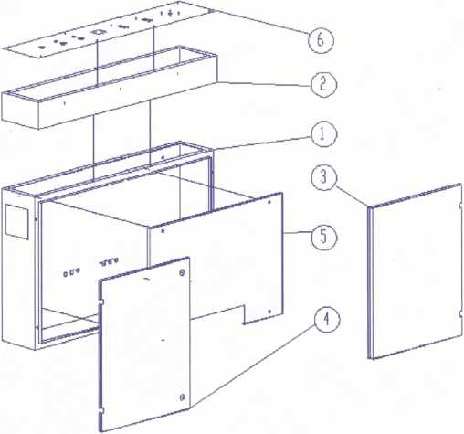

No | Name | Qty | Remark
1 | Control box | 1 | Plastic spraying
2 | Top cover of control box | 1
3 | Right door of electric box | 1
4 | Left door of electric box | 1
5 | Distribution board | 1 | zinc plating-coloring
6 | Panel | 1 | screen printing

- Technical Parameters of the Machine

Model | YX-4525B
Air duct outlet | Inside both sides, lower side
Heating tube | Below the furnace channel
Power Supply | 3φ415V 50Hz
power | 20kW
temperature | 30-200℃
Packaging speed | 20-60pcs/Min
Conveyor belt speed | 1minute/30meter
Overall dimensions | L2100*W1400*H1450 mm
Furnace/tunnel mouth size | L1800*W800*H500 mm
Package size | L1200*W650*H450 mm
Horizontal height of conveyor belt | 800±50mm
Mechanical weight | 300KG
Load of conveyor line | 40KG
Use shrink film | 0.019-0.030
Shrink film type | POF、PVC、PP

- Installation of Machine
A) Open the upper cover of the packing case and remove the four side plates of the packing case;
B) Unscrew the four anchor bolts at the bottom of the machine;
C) Lift out the main body of the machine and place it in a stable and vibration free place;
D) Remove the protective film on the machine body;
E) In order to prevent the conveyor from falling off during transportation, we have installed hooks on the conveyor bar at the bottom of the machine before shipment, which should be removed before starting up, otherwise the machine will not work;
F) Adjust the anchor bolts at the bottom of the machine to adjust the horizontal height of the machine and prevent the machine from sliding during operation;
G) Connect wires according to the voltage shown on the nameplate. Note: be sure to connect the ground wire.

- Operation Method of Machine
A) Turn on the main power switch, and then turn on the air supply switch. At the same time, check the direction of the wind wheel. The correct direction should be counterclockwise. If not, replace the phase line;
B) Press the conveying button, the conveying roller and chain will rotate, and the conveying speed can be adjusted through the inverter knob on the panel;
C) Open the protective cover of the temperature controller, turn the knob on the temperature controller, and set the temperature to 150-200 ℃ as required;
D) When the temperature rises to the set value, the green indicator of the temperature controller turns red, and the heating of the heating tube will be suspended;
E) At this time, the product can be placed for shrink packaging;
F) If the air volume is too large during operation, the air adjusting plate in the furnace can be adjusted;
G) Please pay special attention to: press the stop button to stop the heating of the heating tube before shutting down the machine after work;
H) Open the heat insulation curtain to make the fan and conveyor run normally for about 10 minutes, and shut down after the temperature drops to 100 ℃, so as to extend the service life of the machine;
I) Finally, press the emergency stop button to turn off the conveying and air supply switches and cut off the power supply.

- Maintenance of Machine
A) After the machine finished works, the residues and dust on the machine body and the conveying roller shall be removed;
B) Regularly check the lubricating oil in the motor gearbox of the conveyor line;
C) Make a comprehensive inspection of the machine once a month, and open the distribution box to remove dust and debris;
D) The chain and other moving parts shall be replenished with lubricating oil in time.

- Circuit Diagram of the Machine

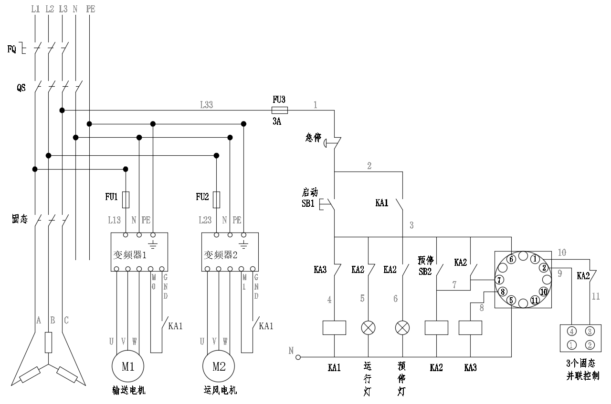

- Troubleshooting
Faults | Causes | Troubleshooting
The shrinkage effect is not good | Reversal of air blower | Replace the phase line
The shrinkage effect is not good | Temperature too low | Adjust temperature
The shrinkage effect is not good | Too high temperature | Adjust temperature
The shrinkage effect is not good | The conveyor belt runs too fast | Adjust speed
The shrinkage effect is not good | Air volume is too large or too small | Adjust air volume
Large machine noise | The conveying motor lacks lubrication | Add lubricating oil
No temperature or low temperature after the heating system is opened | The heating tube is damaged | Replace the heating tube
 | Abnormal input power | Check input power
Sudden shutdown | Power supply is loose | Check the power supply
Sudden shutdown | Fuse blown | Check the circuit and replace the fuse

