YX-400LB L type sealer machine
Operation and Maintenance Manual

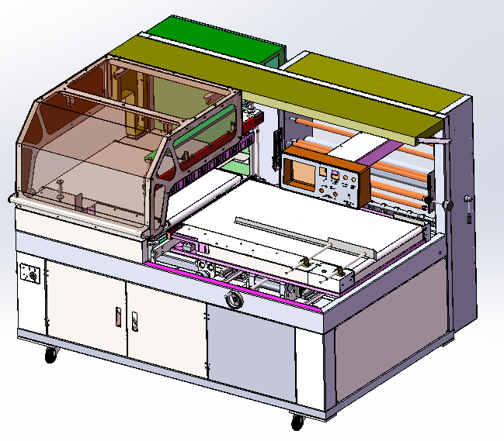

※Please read this manual carefully before using the machine
※Subject to any technical changes without notice

Catalogue

1、 Preface
2、 Machine appearance dimension
3、 Name of Machine Panel and Components
4、 Illustrations of Machine Components
5、 Table of Technical Parameters of the Machine
6、 Installation of Machine
7、 Operation Method of Machine
8、 Maintenance of Machine
9、 Troubleshooting
10、 Circuit Diagram of the Machine
11、 Packing List

- Preface
1. Overview
Thank you very much for purchasing our products. What you are using is a safe, practical and efficient small edge sealing packaging machine.
2. Notes to Manual
A. Please read this manual carefully before using the machine;
B. Please use the machine after mastering the knowledge and precautions of the machine;
C. Please keep this manual properly for reference at any time;
D. Be sure to give this manual to the end user;
E. Due to continuous improvement and improvement of machine performance, the company reserves the right to modify the machine and manual;
F. If you have any good suggestions on this manual or the machine, please contact our company;
3. Safety precautions
A. The circuit breaker and power cord with the same capacity as the machine must be used. The use of circuit breakers with smaller capacity or power lines with smaller wire diameters will cause damage to lines or components;
B. When packaging the liquid, it shall be ensured that the liquid will not drip. If this machine is used to pack liquid objects with poor sealing, it may cause damage to the machine or electric shock to people;
C. Do not use the machine in a highly humid environment, nor let the machine be exposed to a large amount of water vapor;
D. Do not use or place the machine in dusty places;
E. The parts with high temperature warning signs may be exposed to high temperature during operation, so please do not touch them with your hands;
F. When replacing parts, cut off the power supply first and replace them according to the correct steps.
4. Machine performance
A. This machine is suitable for the appearance packaging of food, electronics, toys, books, electrical appliances, bamboo and wood tools, hardware tools, cosmetics, drugs, etc. After packaging, it has beautiful appearance, moisture-proof and scratch proof functions, improving the product image and low packaging cost;
B. The sealing height can be adjusted, and the length of packaged products is unlimited;
C. High quality brand control components are used to ensure stable and reliable operation and low failure rate;
D. The operating system is equipped with a humanized color touch screen, which is easy to understand with pictures and texts;
E. The sealing knife is made of special materials, which has high strength and is not easy to deform. It is coated with DuPont Teflon, which is resistant to adhesion and high temperature. The sealing is stable and firm.
F. The conveying motor adopts the brake function, which makes the movement more accurate;
G. This machine is suitable for all kinds of shrinkable films such as POF, PE, etc.

二、Machine appearance dimension

1、External dimensions of the machine
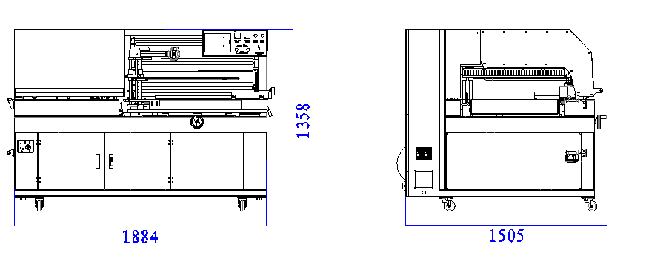

三、Name of Machine Panel and Components
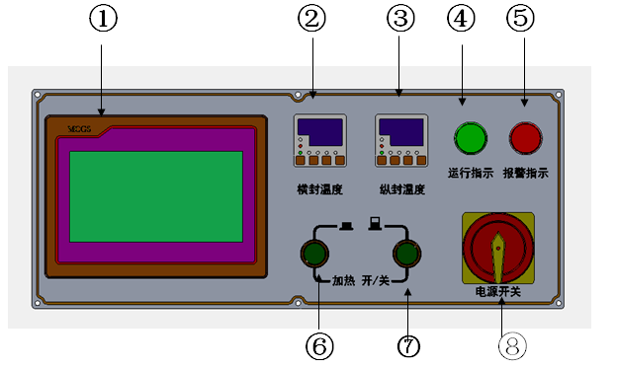
1. Touch screen: operation interface and setting machine parameters;
2. Horizontal sealing temperature controller: set heating temperature;
3. Longitudinal sealing temperature controller: set heating temperature;
4. Running indicator: the machine will run automatically when the light is on, otherwise it will stop automatically;
5. Alarm indicator: alarm;
6. Horizontal seal heating switch: switch;
7. Vertical seal heating switch: switch;
8. Power switch: turn off or connect the main power supply of the machine;

Main interface
Auto interface

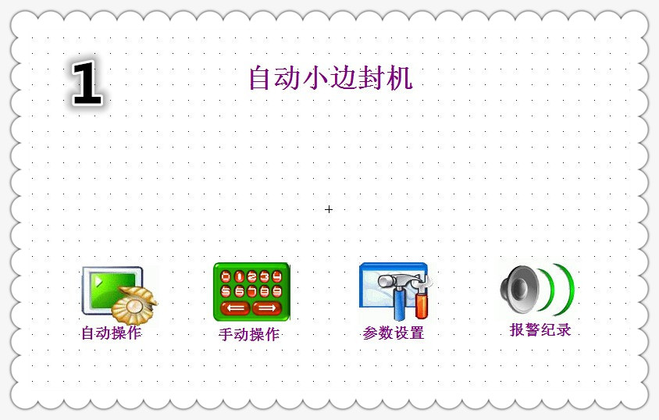
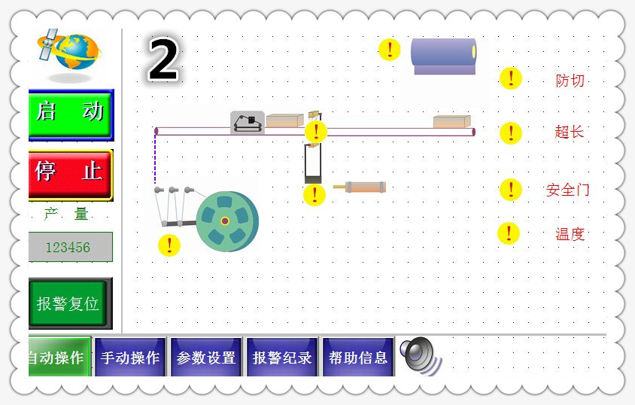

Parameter setting
Interface
Manual Interface

面

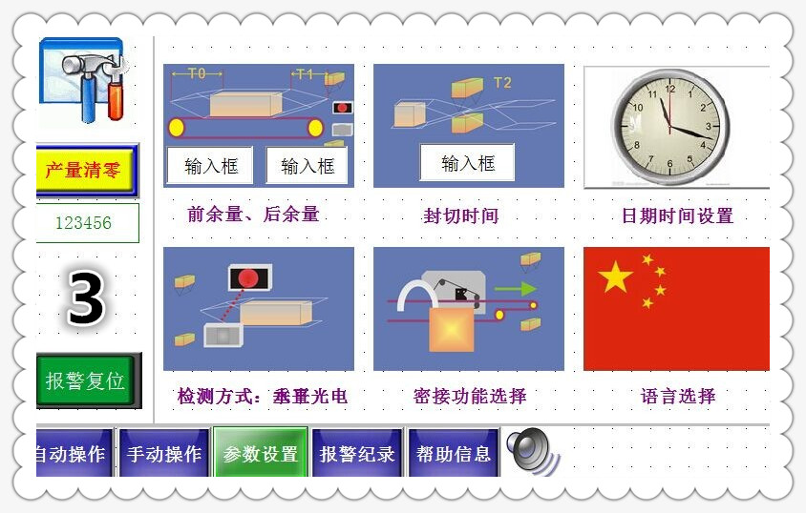
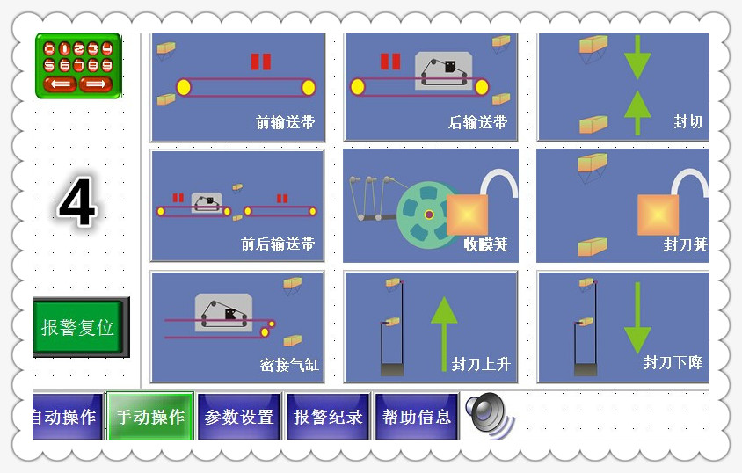

Alarm record
Help interface

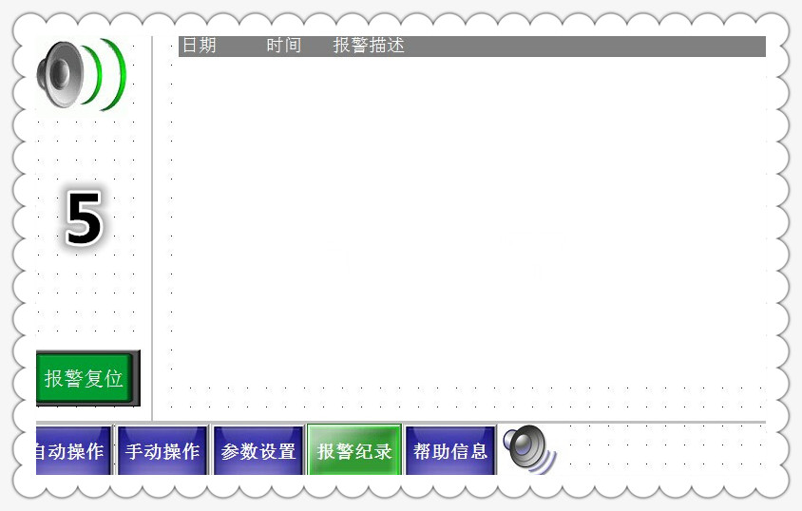
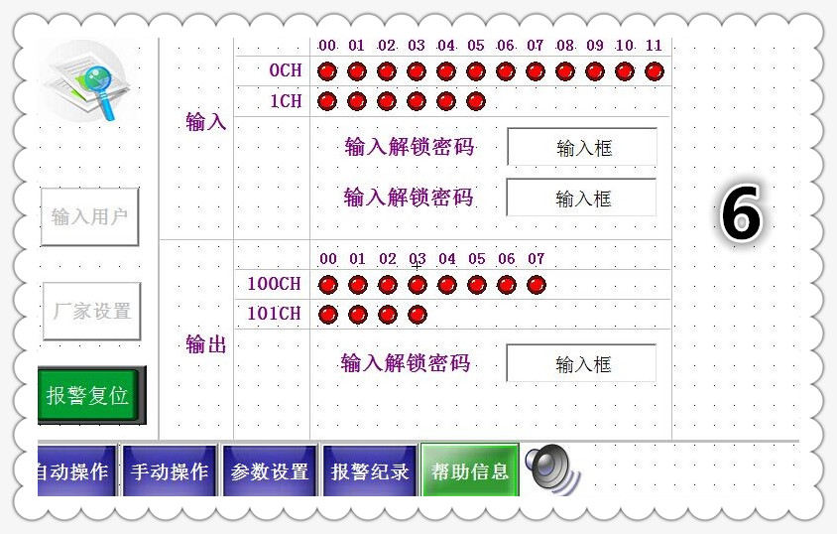

四、Illustrations of Machine Components
1、Machine assembly drawing
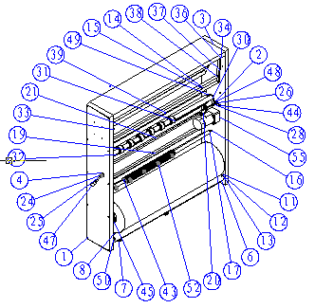


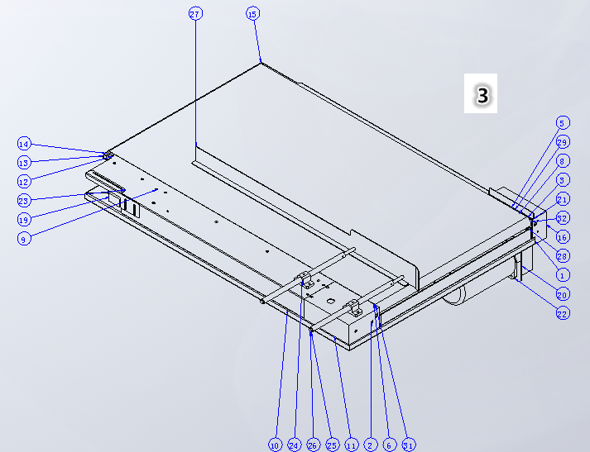



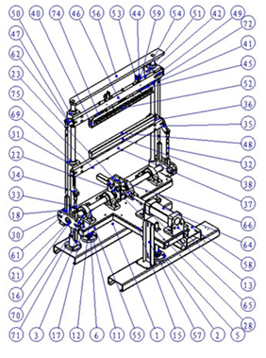
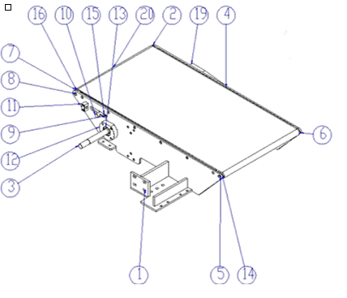


No | Name | Quantity
2 | Film feeding assembly | 1
3 | Front conveyor assembly | 1
4 | Horizontal seal assembly | 1
5 | Rear conveyor assembly | 1

五、Table of Technical Parameters of the Machine

Model | YX-400LB
Power Supply | 3& 415V 50Hz
power | 4kw
Air supply pressure | 6～8kg/mm2
Packaging speed | It varies according to the size of different packages (0-40 pieces/minute)
Sealing and cutting size | Electric height adjustment  Maximum sealing size; L unlimited, W +H ≤700mm  H≤230mm
weight | 400kg

六、Installation of Machine
A. Open the upper cover of the packing case and remove the four side plates of the packing case;
B. Lift out the main body of the machine and place it on a stable ground;
C. Adjust the anchor bolts at the bottom of the machine to adjust the horizontal height of the machine and prevent the machine from sliding during operation;
D. Please wire according to the voltage shown on the nameplate and connect the air source. Note: be sure to connect the ground wire reliably.

七、Operation Method of Machine
1. Turn on the main power switch, and the machine will enter the power on state;
2. Connect the air source and adjust the air pressure to 6.0 ～ 8.0Gg/cm2;
3. Press the control button of the horizontal seal and side seal temperature controller to adjust the horizontal seal temperature to 200~220 ℃ and the side seal temperature to 280~300 ℃;
4. Select appropriate packaging materials according to the required packaging material specifications (calculation formula, height+width+"4~6");
5. Place the packaged products at the beveled edge of the triangular plate on the feeding conveyor line, adjust the triangular plate to 5-8 mm higher than the product, and then adjust the side limit strip to 5-8 mm away from the product, so that the product can run smoothly on the feeding belt line without jamming;
6. With the side stop strip as the benchmark, adjust the feeding belt line to the front of the side seal shield, depending on the product margin;
7. Adjust the edge seal height to the height of the object to be packaged ½ , subject to the section of membrane puller;
8. Adjust the horizontal seal height to the height of the object to be packed ½ The height of the contact surface can be changed by touching the up and down buttons on the touch screen based on the contact between the sealing knife and the lower knife base;
9. Select the detection method (horizontal photoelectric, vertical photoelectric) suitable for the product according to the height and shape of the product;
10. Draw the packaging materials to the side seal in order according to the schematic direction, rotate the lifting handle of the side seal to make the packaging materials flat in the film pulling belt, reset the lifting handle, touch the discharge belt to run, and then pull the waste film to the reel according to the film collecting schematic diagram after the waste film is removed;
11. After the operation interface is switched to the automatic menu, start the automatic operation. After putting in the articles to be packaged for trial production, check whether the front and rear margins are appropriate. Adjust them by turning to the parameter setting menu, and batch production can be started until they are appropriate;
12. After the work is completed, turn off the heating button, turn off the main power supply and turn off the air supply.
八、Maintenance of Machine
A. After the machine works, remove the residues and dust of the machine;
B. Regularly check all sliding and running parts and add lubricating oil;
C. Regularly remove the carbon deposit on the sealing knife. It is forbidden to use metal parts to remove it
D. The overall performance shall be checked once a month.

九、Troubleshooting
Trouble | Causes | Troubleshooting
The machine is not powered | The power cord is not connected or the main power supply is not turned on | Connect the power line according to the phase line and turn on the main power supply
The horizontal seal does not work | The air source is not connected or the air pressure is low | Connect the air source and adjust the air pressure
The horizontal seal does not work | Horizontal seal safety lock | Unlock the horizontal seal
The horizontal seal does not work | Solenoid valve failure | Replace solenoid valve
The horizontal seal does not work | Warning lamp flashes | Reset alarm button
Side seal does not work | The air source is not connected or the air pressure is low | Connect the air source and adjust the air pressure
Side seal does not work | Cylinder guide column stuck | Add lubricating oil
Side seal does not work | Solenoid valve failure | Replace solenoid valve
Side seal does not work | Warning lamp flashes | Reset alarm button
Packing materials run off course | Improper location of packaging materials | Adjust position
Packing materials run off course | Packaging material specification is inconsistent | Select appropriate packaging materials
Packing materials run off course | Packing material traction error | Traction according to the diagram
Packing materials run off course | Angle deviation of film clamping wheel | Adjust the proper angle
Packing materials run off course | Front margin is too small | Margin parameters before adjustment
Waste fracture | The packing materials do not conform to the specifications | Select appropriate packaging materials
Waste fracture | The boundary seal meets the horizontal seal too large | Adjust the edge seal position
Waste fracture | Packing materials run off course | Running deviation elimination according to packaging materials
Waste fracture | Packing material traction error | Traction according to the diagram
Waste fracture | The counterweight is too heavy | Adjusting counterweight
The horizontal seal is broken | Low air pressure | Adjust air pressure
The horizontal seal is broken | Abnormal temperature | Adjust the appropriate temperature
The horizontal seal is broken | High temperature adhesive tape and silica gel strip are damaged | Replace the high-temperature adhesive tape and silica gel strip
The horizontal seal is broken | Excessive carbon deposit on horizontal sealing knife | Remove carbon deposits
The horizontal seal is broken | The spring pressure is too small or too large | Adjust spring pressure
The horizontal seal is broken | The horizontal sealing knife is damaged | Replace the horizontal sealing knife
The edge seal seal is broken | Low air pressure | Adjust air pressure
The edge seal seal is broken | Abnormal temperature | Adjust the appropriate temperature
The edge seal seal is broken | Excessive carbon deposit on edge sealing knife | Remove carbon deposits
The edge seal seal is broken | The packaging materials do not run smoothly | Smooth adjustment and operation
The edge seal seal is broken | Edge sealing knife damaged | Replace the edge sealing knife
Temperature anomaly | Poor contact and loose connection | Fasten all connecting wires
Temperature anomaly | The heating tube and thermocouple are damaged | Replace heating tube and thermocouple
Temperature anomaly | Solid state relay damaged | Replace solid state relay
Temperature anomaly | The thermostat is damaged | Replace the thermostat
Prevent cut exception | High anti cutting sensitivity | Adjust the sensing block
Prevent cut exception | The rear margin of the package is too small | Adjusted allowance parameters
Prevent cut exception | The magnetic spring switch position is inappropriate | Adjust the magnetic spring switch position

十、Circuit Diagram of the Machine

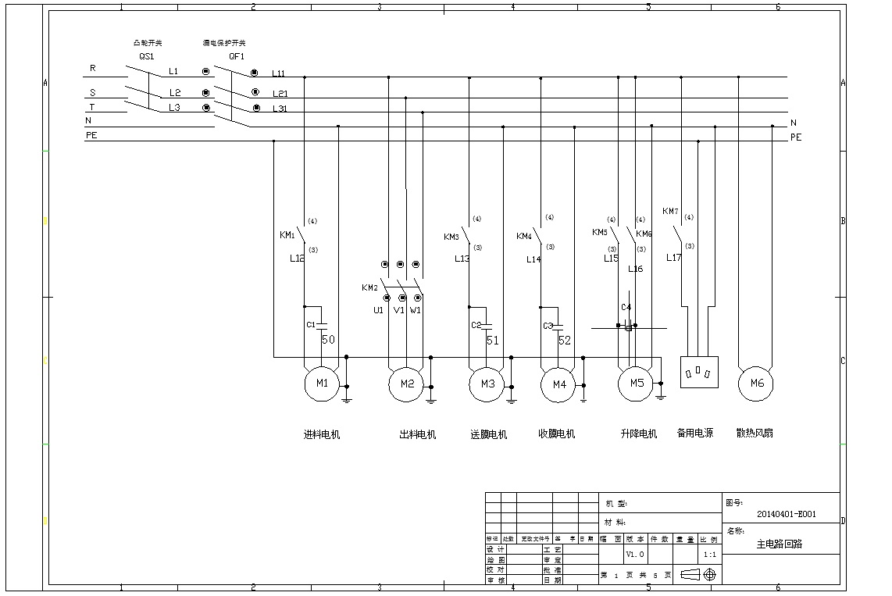

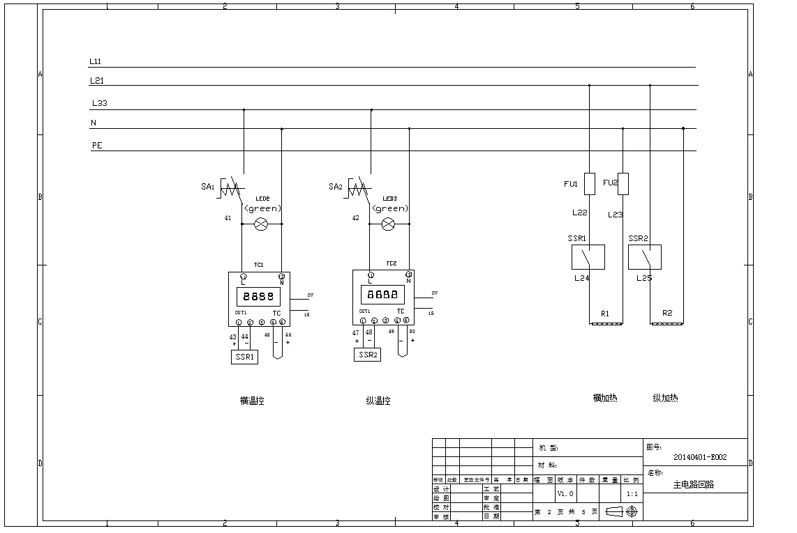

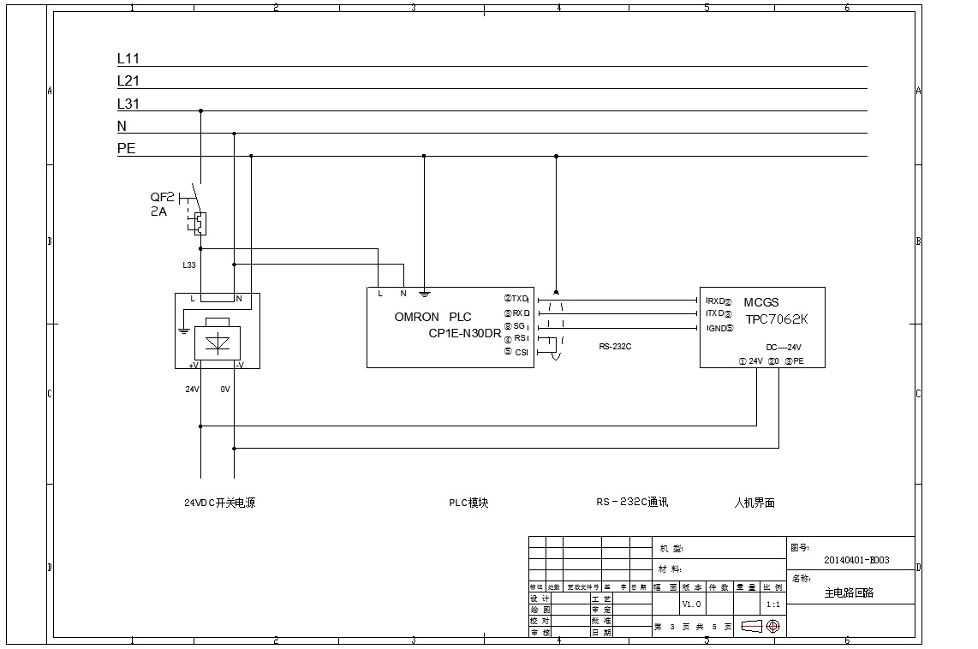

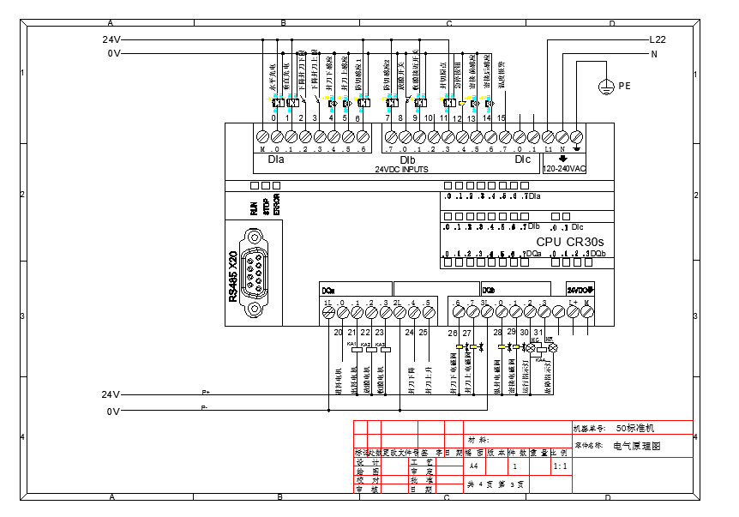
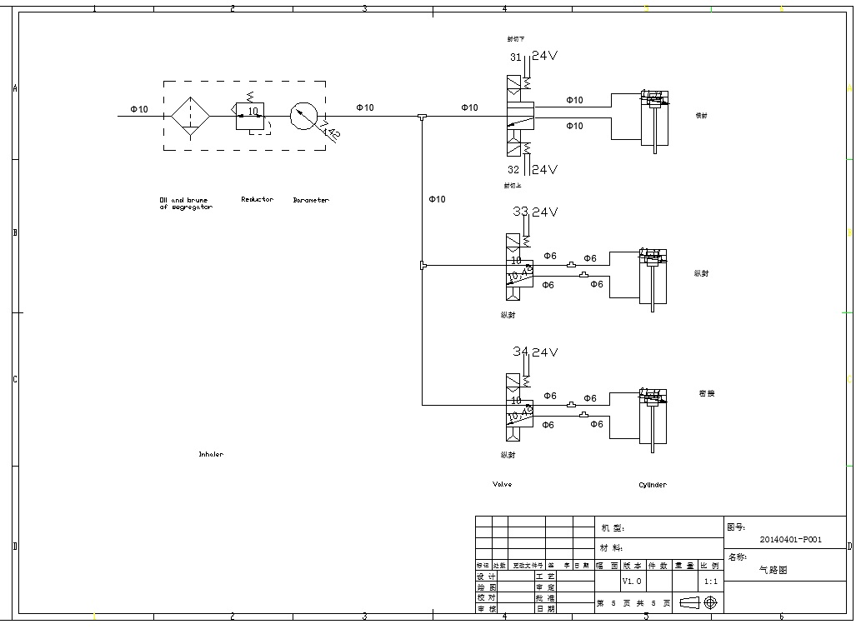

十、Packing List

No | Name | Spec | Quantity
1 | Machine host |  | 1 set
2 | The toolkit |  | 1
3 | Hex socket wrench |  | 1 set
4 | Adjustable wrench |  | 1
5 | The screwdriver |  | 1
6 | thermocouple |  | 1
7 | The silicone article |  | 1
8 | The high temperature tape |  | 1 roll

